Press Release
AV Dawson, Middlesbrough
09 February 2022

539 words

AV Dawson Hails Apprenticeship Success as First HGV Driver Qualifies

An apprentice HGV driver is celebrating after being the first to successfully qualify as a Class 1 driver under a new apprenticeship programme.
As the first driver to successfully qualify from the new ‘AV Dawson driver training academy’, Michael Taylor from Middlesbrough astounded the employer with his quick progress - completing the course in just under three months. Michael’s quick progress means he will now be employed by the business as a fully qualified Class 1 driver.
The scheme, developed by AV Dawson was set up in response to the national shortage of Class 1 HGV Drivers. The logistics sector, like many others is facing a huge skills shortage and although not a new issue the combination of Covid and Brexit has put increasing pressure on the industry.
Paul Scott, AV Dawson’s transport manager said “Michael joined AV Dawson in November and his progress has been outstanding, we didn’t predict or expect him to complete his training so quicky and at such a consistently high standard.
“Michael has joined the business with drive and determination and he is the perfect example of what can be achieved when you really put your mind to it. Now Michael has his licence he will now undergo a period of additional internal training and assessment and spend time with our transport assessor to work on refining his skills as a driver.
“We have received a lot of interest in our HGV apprenticeship programme and although this cohort is full, we will be looking to recruit again later in the year.
“Our business is growing, so the challenge to recruit more drivers is exacerbated when combined with a national shortage. We have seen foreign nationals employed in this sector leave due to Brexit, a backlog in DVLA testing for new drivers and older drivers taking early retirement after furlough and not wanting to continually retrain to meet the latest industry standards.
“Although there are challenges in the market, we want to recruit people that share our company values and are loyal to the business. This is why we review our wage structure on a regular basis, offer an excellent work life balance and provide additional benefits including company bonus, company perks and emotional health and wellbeing support”.
Michael applied to the company’s apprenticeship scheme after hearing the call for Class 1 driver apprentices on the local radio.
Michael said: “I already had some previous experience driving smaller vehicles for a local council and after hearing AV Dawson’s radio campaign advertising the apprenticeship scheme and the benefits of becoming an HGV Class 1 driver, I jumped at the chance to apply for the role. This opportunity has not only allowed me to develop my transferable skills but it has given me a career path that I know I will really enjoy.
“AV Dawson is one of the most recognisable businesses in the area and has an excellent reputation as an employer. The whole team has been incredible, especially the support and guidance I have received from the transport department, without this it would have been impossible to gain my Class 1 licence in the time I have and I am incredibly grateful for the opportunity.”

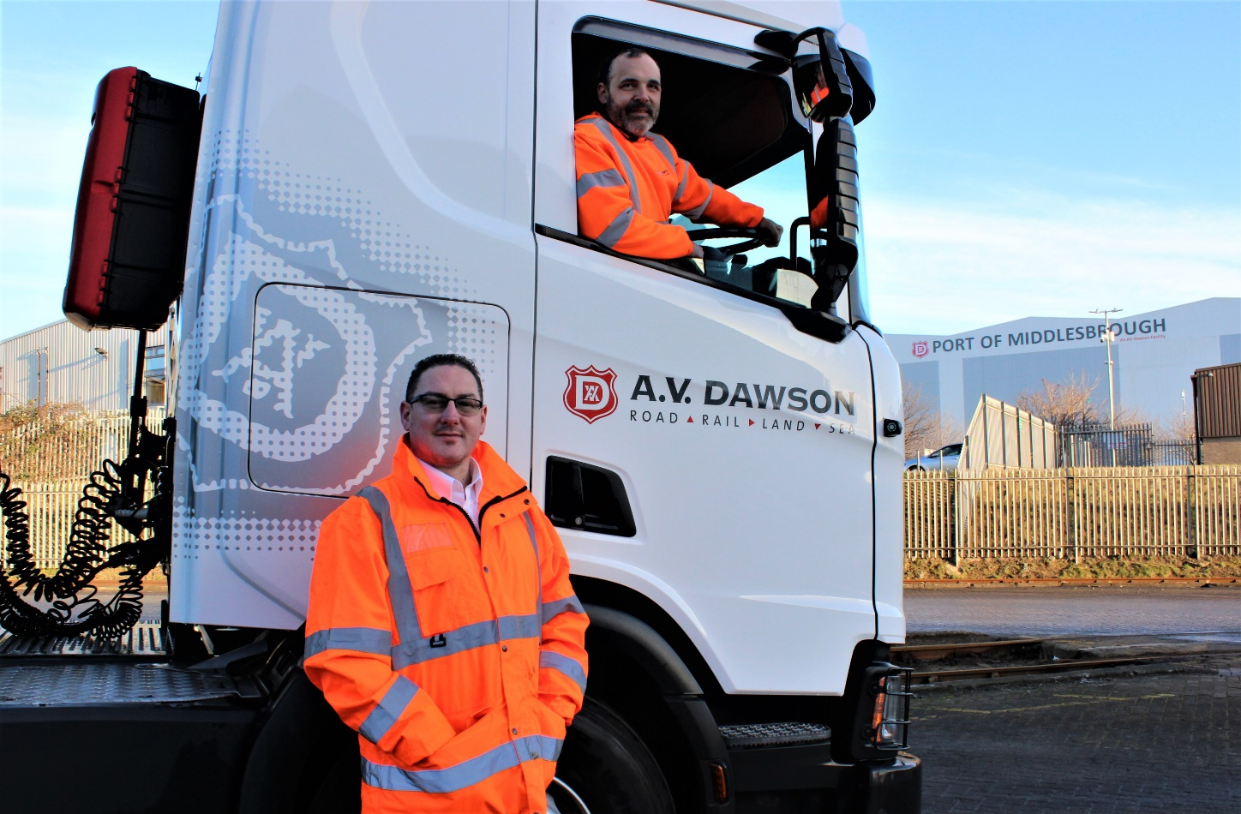
Photo caption: AV Dawson Transport (L- R Paul Scott AV Dawson transport manager and Michael Taylor AV Dawson Class 1 HGV driver)
***ENDS***

Contact:
Anthony Suddes, AV Dawson Marketing & Communications
anthony.suddes@av-dawson.com
+44 (0)1642 256843 or (0)7808 761125

Notes to Editors:
Located on the River Tees in North East England, AV Dawson’s Port of Middlesbrough provides a full freight logistics service across a number of sectors including energy and renewables, construction, agriculture, automotive and waste. The 40-hectare facility boasts deep-water berths, market-specific rail terminals including a container park and climate-controlled metals hub, all supported by its road transport fleet.
AV Dawson Limited, the Teesside business which owns and operates Port of Middlesbrough, is a third-generation family business with an 80-year track record in logistics. Employing 240 people across the region AV Dawson is dedicated to the development and improvement of its employees and the community in which it operates.

AV Dawson is now embarking on a £10m master plan to invest further in its Middlesbrough port facility - supporting its customers and positioning the business for future growth. The three-year plan includes the construction of a renewable energy plant, a new head office and developments to the port’s quayside to accommodate larger vessels.

